**Security Considerations**

**1. Networking Security**

HTTPS Implementation: All communications between users and the web app are secured using HTTPS. This ensures that data transmitted is encrypted, protecting it from eavesdropping and man-in-the-middle attacks.

Web Application Firewall (WAF): A WAF was integrated to monitor and filter incoming traffic to the web app. This helps to block malicious requests, including those attempting SQL injection, cross-site scripting (XSS), and cross-site request forgery (CSRF) attacks. (Cloudflare, n.d.)

Network Segmentation: The application architecture was designed to segment different components (e.g., frontend, backend, database) within the network. This reduces the risk of lateral movement by attackers if one segment is compromised. (vmware, 2024)

**2. Vulnerabilities Addressed**

Input Validation and Sanitization: All user inputs are validated and sanitized to prevent injection attacks, such as SQL injection and XSS. We implemented strict validation rules and used prepared statements for database queries.

Security Misconfiguration Prevention: Regular audits were conducted to ensure that all configurations are secure. This includes disabling default accounts, removing unnecessary services, and ensuring that error messages do not reveal sensitive information.

Cross-Site Request Forgery (CSRF) Protection: Anti-CSRF tokens are generated for forms that perform state-changing operations. This ensures that requests are legitimate and originated from authenticated users.  (cyber_pix, 2024)

**3. Threat Mitigation Strategies**

Regular Security Testing: We employed automated security testing tools to conduct vulnerability scans and penetration testing throughout the development lifecycle. This helped identify potential weaknesses before deployment.

Secure Authentication: Implemented ASP.NET Identity for user authentication, which includes features like password hashing, account lockout after multiple failed attempts, and multi-factor authentication (MFA) options for enhanced security.

Logging and Monitoring: Comprehensive logging mechanisms were established to track user activities and system events. This allows for real-time monitoring of suspicious activities and facilitates forensic investigations if a breach occurs. (Lutkevich, 2021)

**4. Data Protection**

Encryption of Sensitive Data: Sensitive information such as payment details is encrypted both in transit (using TLS) and at rest (using strong encryption algorithms). This ensures that even if data is intercepted or accessed unauthorizedly, it remains unreadable.

Compliance with Regulations: The application was designed to comply with relevant data protection regulations (e.g., GDPR). User consent is obtained for data collection, and users have control over their personal information. (Imperva, 2023)

**5. User Education**

Security Awareness: Users are provided with information on best practices for account security, such as creating strong passwords and recognizing phishing attempts. This helps empower them to protect their accounts.

By addressing these standard security considerations in our web app development process, we have created a robust framework that minimizes vulnerabilities and enhances the overall security posture of the Bumblebee Foundation web application. Continuous monitoring and updates will ensure that we remain vigilant against emerging threats in the evolving cybersecurity landscape.

**Predicted Monthly Running Costs**

| **Cost Item** | **Monthly Cost (ZAR)** | **Notes** |
| --- | --- | --- |
| **Hosting (Microsoft Azure)** | 1,500 | Based on estimated usage and required resources for a non-profit web app. |
| **Domain Registration** | 100 | Annual cost divided by 12 months. |
| **SSL Certificate** | 200 | Monthly cost for maintaining HTTPS security. |
| **Payment Processing Fees** | 300 | Estimated based on transaction volume and average donation amounts. |
| **Maintenance & Updates** | 1,000 | Regular updates, security patches, and minor feature enhancements. |
| **Support Services** | 500 | Customer support and technical assistance costs. |
| **Marketing & Outreach** | 1,000 | Budget for digital marketing campaigns to attract donations. |
| **Miscellaneous Costs** | 400 | Other unforeseen expenses or minor tools/services needed. |

**Assumptions**

* **Initial monthly donations:** ZAR 10,000
* **Expected growth rate in donations:** 10% per month
* **Increase in user registrations:** Anticipated to grow by 15% per month as awareness increases.

**Year 1 Projections**

| **Month** | **Monthly Donations (ZAR)** | **Cumulative Donations (ZAR)** | **User Registrations** |
| --- | --- | --- | --- |
| Month 1 | 10,000 | 10,000 | 100 |
| Month 2 | 11,000 | 21,000 | 115 |
| Month 3 | 12,100 | 33,100 | 132 |
| Month 4 | 13,310 | 46,410 | 152 |
| Month 5 | 14,641 | 61,051 | 174 |
| Month 6 | 16,105 | 77,156 | 200 |
| Month 7 | 17,715 | 94,871 | 230 |
| Month 8 | 19,487 | 114,358 | 265 |
| Month 9 | 21,436 | 135,794 | 305 |
| Month 10 | 23,579 | 159,373 | 350 |
| Month 11 | 25,937 | 185,310 | 402 |
| Month 12 | 28,531 | 213,841 | 462 |

Year-End Summary for Year 1

* **Total projected donations by end of Year 1:** R213,841
* **Total user registrations by end of Year 1:** 462 users

**Year 2 Projections**

| **Month** | **Monthly Donations (ZAR)** | **Cumulative Donations (ZAR)** | **User Registrations** |
| --- | --- | --- | --- |
| Month 13 | 31,384 | 245,225 | 530 |
| Month 14 | 34,522 | 279,747 | 610 |
| Month 15 | 37,974 | 317,721 | 700 |
| Month 16 | 41,771 | 359,492 | 805 |
| Month 17 | 45,948 | 405,440 | 925 |
| Month 18 | 50,543 | 455,983 | 1060 |
| Month 19 | 55,597 | 511,580 | 1210 |
| Month 20 | 61,157 | 572,737 | 1390 |
| Month 21 | 67,273 | 640,010 | 1590 |
| Month 22 | 73,999 | 713,009 | 1820 |
| Month 23 | 81,399 | 794,408 | 2080 |
| Month 24 | 89.538 | 883.946 | 2360 |

Year-End Summary for Year Two

* **Total projected donations by end of Year Two:** R883,946
* **Total user registrations by end of Year Two:** 2360 users

**Change Management Strategy**

Successfully managing the adoption of the Bumblebee Foundation web app involves a comprehensive approach that addresses both organizational and user-level adoption. Below is an outline of our strategy, including how and why the organization and users will adopt the software, as well as specific tactics to facilitate this process.

**1. Organizational Adoption**

**How and Why the Organization Will Adopt the Software**

* **Alignment with Mission**: The web app is designed to directly support the Bumblebee Foundation's mission of connecting offshore sponsors with local initiatives. By providing a streamlined donation process and transparent reporting, the software enhances the foundation's ability to achieve its goals.
* **Operational Efficiency**: The app automates several manual processes related to donations, user management, and reporting. This efficiency reduces administrative burdens, allowing staff to focus on strategic initiatives rather than routine tasks.
* **Data-Driven Insights**: The software includes analytics features that provide insights into donor behavior, campaign effectiveness, and project impact. This data will inform decision-making and improve resource allocation.

**2. User Adoption**

**How and Why Users Will Adopt the Software**

* **User-Friendly Interface**: The web app is designed with an intuitive interface that simplifies navigation and donation processes. Users will find it easy to engage with the platform, which encourages regular use.
* **Clear Value Proposition**: Users will understand the impact of their contributions through stories, updates, and transparent reporting provided by the app. This connection fosters a sense of community and encourages ongoing support.
* **Security and Trust**: By implementing robust security measures (e.g., HTTPS, data encryption), users will feel confident in making donations through the platform. Trust is crucial for user adoption in any financial transaction.

**3. Strategy for Gaining Adoption**

**Organizational Strategy**

* **Stakeholder Engagement**: Involve key stakeholders early in the development process to gather feedback and ensure that their needs are met. This buy-in creates advocates for the software within the organization.
* **Training Sessions**: Conduct training workshops for staff to familiarize them with the new system. Providing hands-on experience will help ease concerns and build confidence in using the software.
* **Change Champions**: Identify and empower change champions within the organization who can advocate for the new system, share success stories, and assist colleagues in adapting to the new processes.

**User Strategy**

* **Marketing Campaigns**: Launch targeted marketing campaigns to raise awareness about the new web app among potential donors. Highlight its features, benefits, and ease of use through social media, newsletters, and community events.
* **Incentives for Early Adopters**: Offer incentives such as exclusive updates on project impacts or recognition for early adopters who make donations through the new platform. This can create buzz and encourage participation.
* **Feedback Mechanisms**: Implement feedback channels (e.g., surveys, user forums) to gather user input on their experience with the app. Actively addressing concerns or suggestions will enhance user satisfaction and promote continued engagement.

**4. Continuous Support and Improvement**

* **Ongoing Support**: Establish a support system (e.g., help desk, FAQs) to assist users with any issues they encounter while using the app. Prompt support builds trust and encourages users to continue using the platform.
* **Regular Updates**: Keep users informed about new features or improvements based on their feedback. Regular updates demonstrate that their input is valued and that the organization is committed to enhancing their experience.

**Conclusion**

By focusing on both organizational and user-level adoption strategies, we aim to ensure a smooth transition to the Bumblebee Foundation web app. Through stakeholder engagement, effective training, targeted marketing efforts, and ongoing support, we can foster a culture of acceptance and enthusiasm around this new tool. Ultimately, successful adoption will enable the foundation to maximize its impact in connecting sponsors with local initiatives in South Africa.

**GitHub Actions Pipeline**

To address the non-functional requirement of rapid deployment of a high-quality application in the Bumblebee Foundation web app project, we implemented a GitHub Actions pipeline. This CI/CD (Continuous Integration/Continuous Deployment) pipeline automates the build, test, and deployment processes, ensuring that every change made to the codebase is efficiently integrated and deployed with minimal manual intervention.

**Functionality of the GitHub Actions Pipeline:**

1. **Trigger Events**: The pipeline is configured to trigger on specific events such as:
   * Code pushes to the main branch.
   * Pull requests created or updated.
   * Scheduled runs for regular maintenance tasks.
2. **Jobs**: Each workflow consists of multiple jobs that run sequentially or in parallel. The main jobs include:
   * **Build Job**: Compiles the application code and prepares it for testing.
   * **Test Job**: Runs automated tests to ensure code quality and functionality.
   * **Deploy Job**: Deploys the application to the production environment if all previous jobs succeed.
3. **Steps**: Each job is composed of individual steps that perform specific tasks, such as:
   * Setting up the environment (installing dependencies).
   * Running unit tests.
   * Building Docker images
   * Deploying to cloud services.
4. **Notifications**: The pipeline can send notifications upon success or failure of builds and deployments, keeping the team informed of the status.

**(What is GitHub Actions? Benefits and examples, n.d.)**

**Diagram of GitHub Actions Pipeline**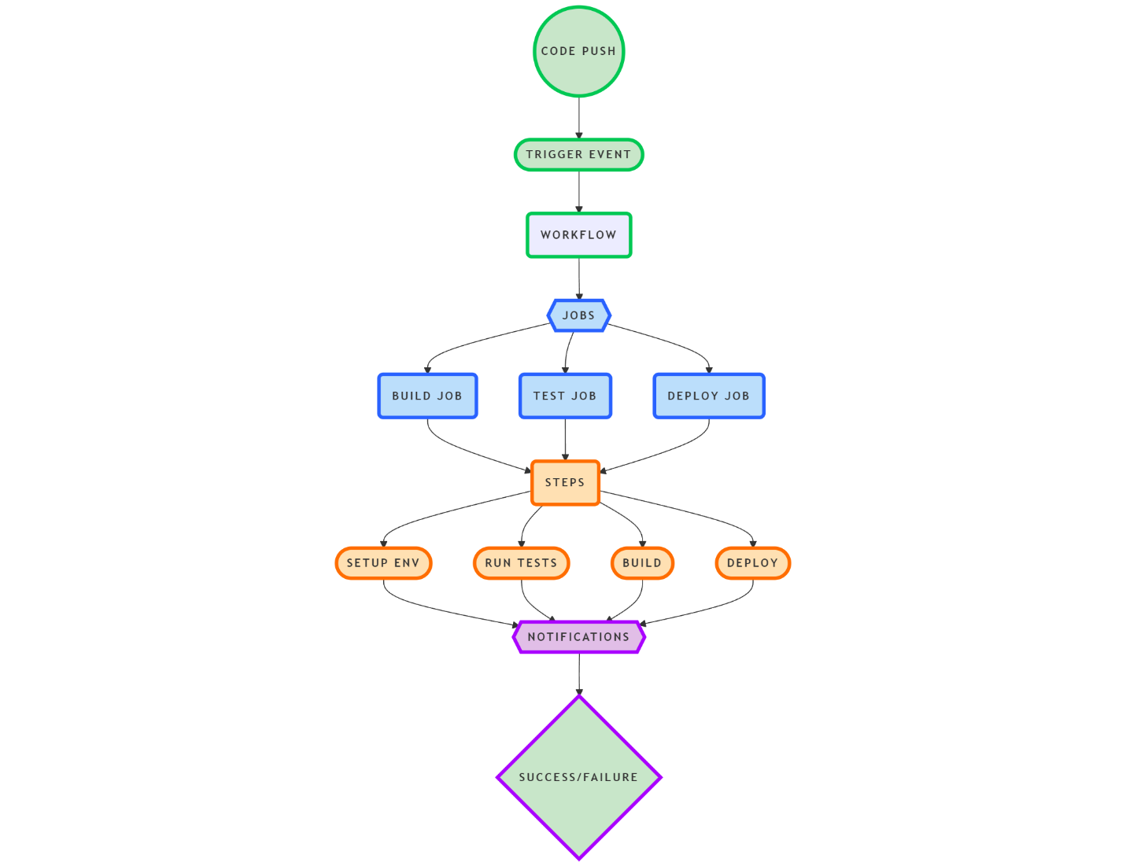

**Benefits of Using GitHub Actions Pipeline**

* **Automation**: Reduces manual effort by automating repetitive tasks, allowing developers to focus on coding rather than deployment logistics.
* **Consistency**: Ensures consistent build and deployment processes across different environments, reducing human error.
* **Rapid Feedback**: Provides immediate feedback on code changes through automated testing, enabling faster iterations and higher quality releases.
* **Scalability**: Easily adapts to growing project needs by adding more jobs or steps as required without significant restructuring.

(Davide 'CoderDave' Benvegnù, 2023)

By leveraging GitHub Actions for our CI/CD pipeline, we ensure that our deployment process is not only rapid but also reliable and efficient, meeting the non-functional requirements essential for delivering a high-quality application for the Bumblebee Foundation.

**Bibliography**

**Cloudflare (n.d.). What is a WAF? | Web Application Firewall explained. [online] Cloudflare. Available at:** [**https://www.cloudflare.com/learning/ddos/glossary/web-application-firewall-waf/**](https://www.cloudflare.com/learning/ddos/glossary/web-application-firewall-waf/)**.**

**vmware (2024). What is Network Segmentation? | VMware Glossary. [online] www.vmware.com. Available at:** [**https://www.vmware.com/topics/network-segmentation**](https://www.vmware.com/topics/network-segmentation)**.**

**cyber_pix (2024). Input Validation and Sanitization: Protecting Your Application from Malicious Input. [online] Medium. Available at:** [**https://medium.com/@use.abhiram/input-validation-and-sanitization-protecting-your-application-from-malicious-input-28fee92ea0d3**](https://medium.com/@use.abhiram/input-validation-and-sanitization-protecting-your-application-from-malicious-input-28fee92ea0d3)**.**

**Lutkevich, B. (2021). What is Risk Mitigation? Definition, Strategies and Planning. [online] SearchDisasterRecovery. Available at:** [**https://www.techtarget.com/searchdisasterrecovery/definition/risk-mitigation**](https://www.techtarget.com/searchdisasterrecovery/definition/risk-mitigation)**.**

**Imperva (2023). What is Data Protection | Principles, Strategies & Policies | Imperva. [online] Learning Center. Available at: <https://www.imperva.com/learn/data-security/data-protection/>.**

**Davide 'CoderDave' Benvegnù (2023). 5 Top Reasons to Use GitHub Actions for Your Next Project. [online] DEV Community. Available at:** [**https://dev.to/n3wt0n/5-top-reasons-to-use-github-actions-for-your-next-project-cga**](https://dev.to/n3wt0n/5-top-reasons-to-use-github-actions-for-your-next-project-cga)**.**